Title of Your Abstract (Arial 12 pt, bold - centered)

Author(s), Arial 11 pt, plain - centered, if there is more than one author, underline the name of the presenting author, for example: John Doe, Robert Braun, Jeanine White

Affiliation, Arial 11 pt, italics – centered, for example:
Laboratory of Organometallic Chemistry and Homogeneous Catalysis,
University of Liège

Text of your abstract, Arial 11 pt, plain – justified text, single spacing, no indentation. Insert one empty line between paragraphs.

Insert figures, schemes, or structures directly into the text. When drawing structures or schemes with ChemDraw or another chemical drawing software, chose the “ACS Document 1996” style (Arial 10 pt for atom labels). For an example, see structures 1 and 2 below.

 |  |  |  |  |  | O | O
 | O |  | S |  |  |  | O
 | O |  | S |  | N |  | O
 |  | N |  |  | N |  | O
O |  | N |  |  |  |  | O
O | N | N
O | H |  |  |  | N |  | O
 | 1 |  |  | 2 |  | O
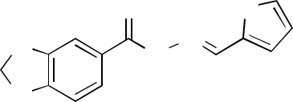
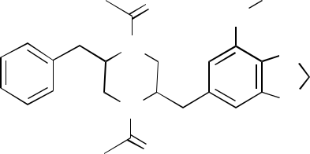

If references are cited, they should be numbered and placed in square brackets before any punctuation mark. Here is an example [1]. The list of references should be located at the end of the abstract after the word References, Arial 10 pt – justified text, single spacing, no indentation, no empty line between references. Please format the references according to the RSC guidelines as in the examples below [1-4].

Your abstract must fit within a single page. Do not change the margins nor the document settings of this template.

Kindly bear in mind that abstracts will not be proofread and copy-edited, therefore the text and graphics will be reproduced exactly as submitted, including any errors or typos that might be present. You are sole responsible for its content.

References

- M. N. Hopkinson, C. Richter, M. Schedler and F. Glorius, Nature, 2014, 510, 485.
- D. M. Flanigan, F. Romanov-Michailidis, N. A. White and T. Rovis, Chem. Rev., 2015, 115, 9307.

- N-Heterocyclic Carbenes: From Laboratory Curiosities to Efficient Synthetic Tools, RSC Catalysis Series, ed. S. Díez-González, Royal Society of Chemistry, Cambridge, 2nd edn, 2017, vol. 27.

- G. Hogarth, in Progress in Inorganic Chemistry, ed. K. D. Karlin, John Wiley & Sons, Hoboken, NJ, 2005, vol. 53, pp. 71–561.

